Lab 08 Generics and Collections

Exercise 1
Question: Store 10 integers in ArrayList; print sum, maximum and reverse list.
Java source code:
import java.util.*;

public class Exercise1IntegerList {
public static void main(String[] args) {
// Create a list of integers and initialize it with values
ArrayList<Integer> numbers = new ArrayList<>(
List.of(4, 8, 2, 9, 1, 6, 3, 10, 5, 7));
int sum = 0;
int maximum = numbers.get(0);
// Iterate through the list to calculate the sum and find the maximum value.
for (int number : numbers) {
sum += number;
if (number > maximum) {
maximum = number;
}
}

System.out.println("List: " + numbers);
System.out.println("Sum: " + sum);
System.out.println("Maximum: " + maximum);

// Reverse the same list after reporting its original order.
Collections.reverse(numbers);
System.out.println("Reverse: " + numbers);
}
}

Expected output (sample):
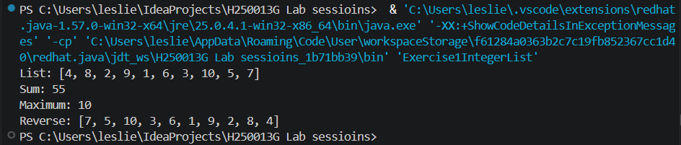Explanation: The loop calculates sum and maximum. Collections.reverse changes the list order.

Exercise 2
Question: Remove duplicate names using a Set.
Java source code:
import java.util.*;
public class Exercise2UniqueNames {
public static void main(String[] args) { List<String> names=List.of("Tariro","Leslie Sarai","Tariro","Rudo"); Set<String> unique=new LinkedHashSet<>(names); System.out.println(unique); }
}
Expected output (sample):
[Tariro, Leslie Sarai, Rudo]
Explanation: A Set stores each value once. LinkedHashSet preserves the original insertion order.

Exercise 3
Question: Generic Stack<T> using ArrayList with push, pop, peek, isEmpty.
Java source code:
import java.util.*;
public class Exercise3GenericStack {
static class Stack<T> { private final ArrayList<T> items=new ArrayList<>(); void push(T value){items.add(value);} T pop(){if(isEmpty())throw new IllegalStateException("Empty stack");return items.remove(items.size()-1);} T peek(){if(isEmpty())throw new IllegalStateException("Empty stack");return items.get(items.size()-1);} boolean isEmpty(){return items.isEmpty();} }
public static void main(String[] args) { Stack<String> s=new Stack<>(); s.push("Java");s.push("OOP");System.out.println(s.peek());System.out.println(s.pop());System.out.println(s.isEmpty()); }
}
Expected output (sample):
OOP
OOP
false
Explanation: T lets the stack store a chosen reference type. push adds to the end; pop removes the last item (LIFO).

Exercise 4
Question: Count paragraph word frequency with Map, sorted by frequency descending.
Java source code:
import java.util.*;
public class Exercise4WordFrequency {
public static void main(String[] args) { String text="java oop java classes oop java"; Map<String,Integer> freq=new HashMap<>(); for(String word:text.split(" ")) freq.merge(word,1,Integer::sum); freq.entrySet().stream().sorted(Map.Entry.<String,Integer>comparingByValue().reversed().thenComparing(Map.Entry.comparingByKey())).forEach(e->System.out.println(e.getKey()+": "+e.getValue())); }
}
Expected output (sample):
java: 3
oop: 2
classes: 1
Explanation: Map stores each word and count. The stream sorts by count descending, then word alphabetically for ties.

Exercise 5
Question: Generic bubbleSort bounded by Comparable; test Integer[] and String[].
Java source code:
import java.util.Arrays;
public class Exercise5BubbleSort {
static <T extends Comparable<T>> void bubbleSort(T[] arr) { for(int i=0;i<arr.length-1;i++) for(int j=0;j<arr.length-1-i;j++) if(arr[j].compareTo(arr[j+1])>0){T temp=arr[j];arr[j]=arr[j+1];arr[j+1]=temp;} }
public static void main(String[] args) { Integer[] nums={4,1,3,2}; String[] words={"pear","apple","zebra"}; bubbleSort(nums);bubbleSort(words);System.out.println(Arrays.toString(nums));System.out.println(Arrays.toString(words)); }
}
Expected output (sample):
[1, 2, 3, 4]
[apple, pear, zebra]
Explanation: Comparable provides compareTo() for ordering. int[] cannot be used because generic type parameters require reference types, such as Integer[].

